Parallelogram Opposite Angles Theorem

Definition
# Source: AI Source: Provided by: [Data Path: Persons Table -> ID Column: 1, Name_En Column: Motasem Essam] -> From: [ChatGPT] on [7/25/2026]
The Parallelogram Opposite Angles Theorem states:
The opposite angles of a parallelogram are congruent.
For parallelogram $ABCD$:
$$\boxed{∠A=∠C}$$
and
$$\boxed{∠B=∠D}$$
where opposite angles are the angles that do not share a side.
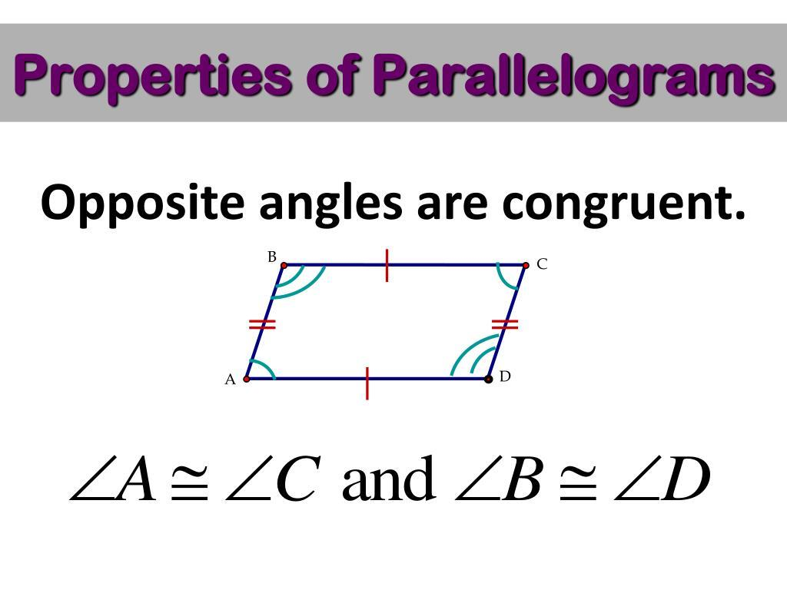
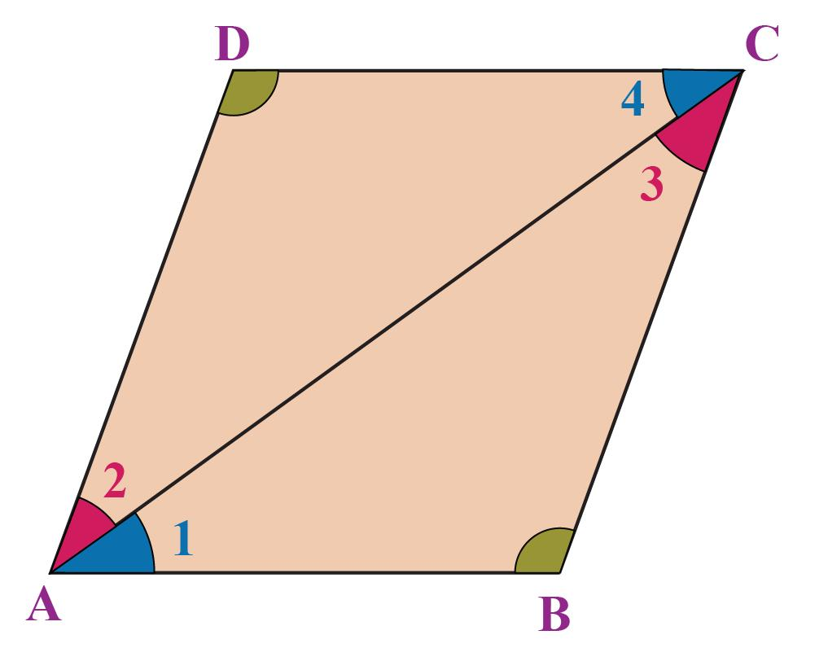
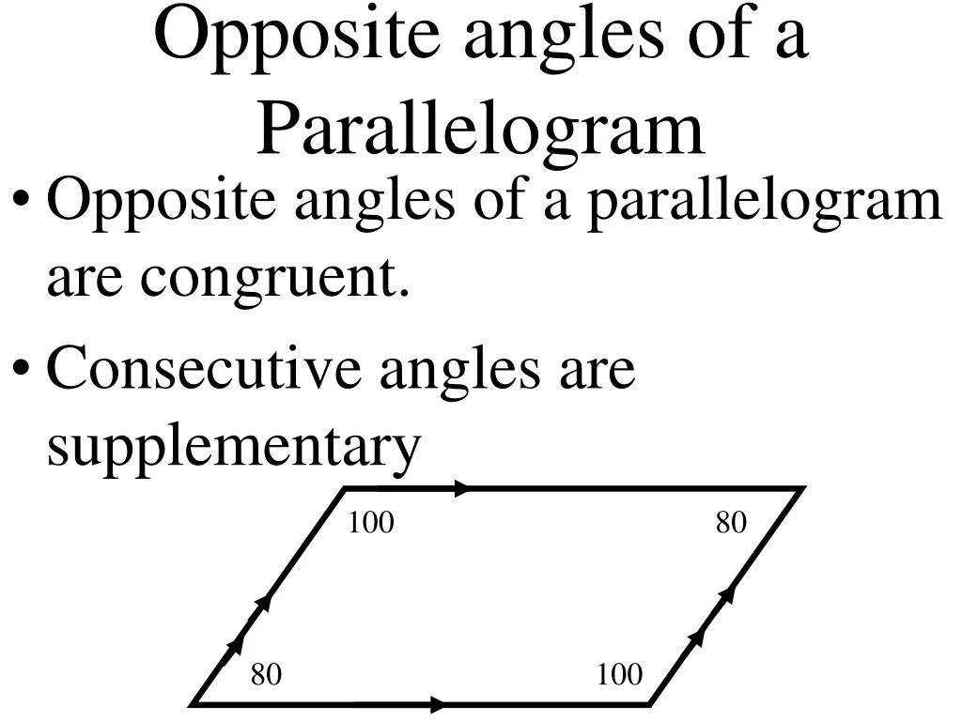
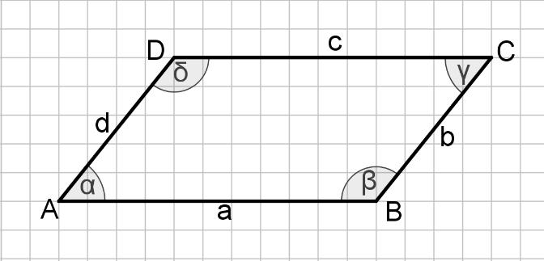
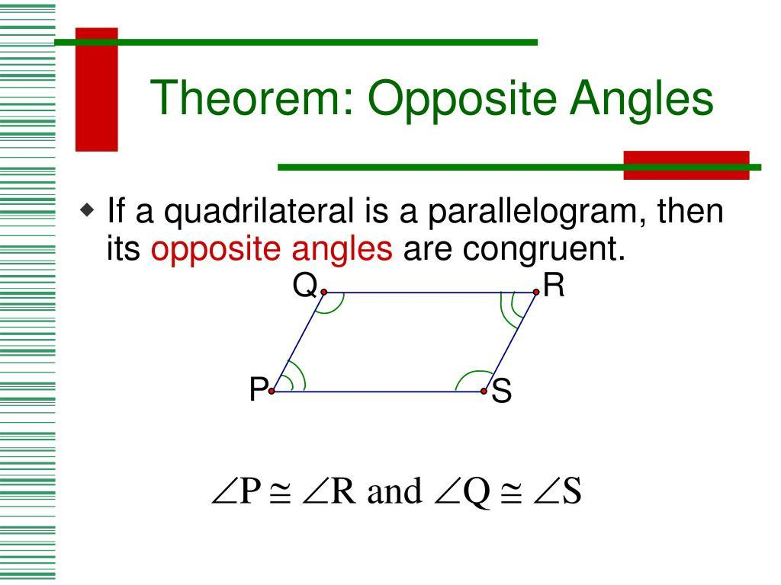

Fundamental Concept
# Source: AI Source: Provided by: [Data Path: Persons Table -> ID Column: 1, Name_En Column: Motasem Essam] -> From: [ChatGPT] on [7/25/2026]
A parallelogram has two pairs of parallel opposite sides:
$$AB∥CD \\ BC∥AD$$
Because of these parallel relationships, the angles formed at opposite vertices have equal measures.
Thus:
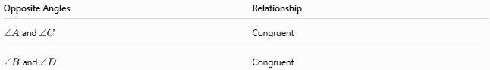
Opposite Angles | Relationship
$∠A$and $∠C$ | Congruent
$∠B$and $∠D$ | Congruent

Mathematical Representation
# Source: AI Source: Provided by: [Data Path: Persons Table -> ID Column: 1, Name_En Column: Motasem Essam] -> From: [ChatGPT] on [7/25/2026]
For parallelogram $ABCD$:
$$\boxed{m∠A=m∠C} \\ \boxed{m∠B=m∠D}$$
Therefore, the sum of all four angles is:
$$m∠A+m∠B+m∠C+m∠D={360}^{∘}$$
Since opposite angles are equal:
$$2m∠A+2m∠B={360}^{∘}$$
so:
$$\boxed{m∠A+m∠B={180}^{∘}}$$
This also leads to the Consecutive Angles Theorem.

Proof
# Source: AI Source: Provided by: [Data Path: Persons Table -> ID Column: 1, Name_En Column: Motasem Essam] -> From: [ChatGPT] on [7/25/2026]
Consider parallelogram $ABCD$:
$$AB∥CD \\ BC∥AD$$
Draw diagonal $AC$.
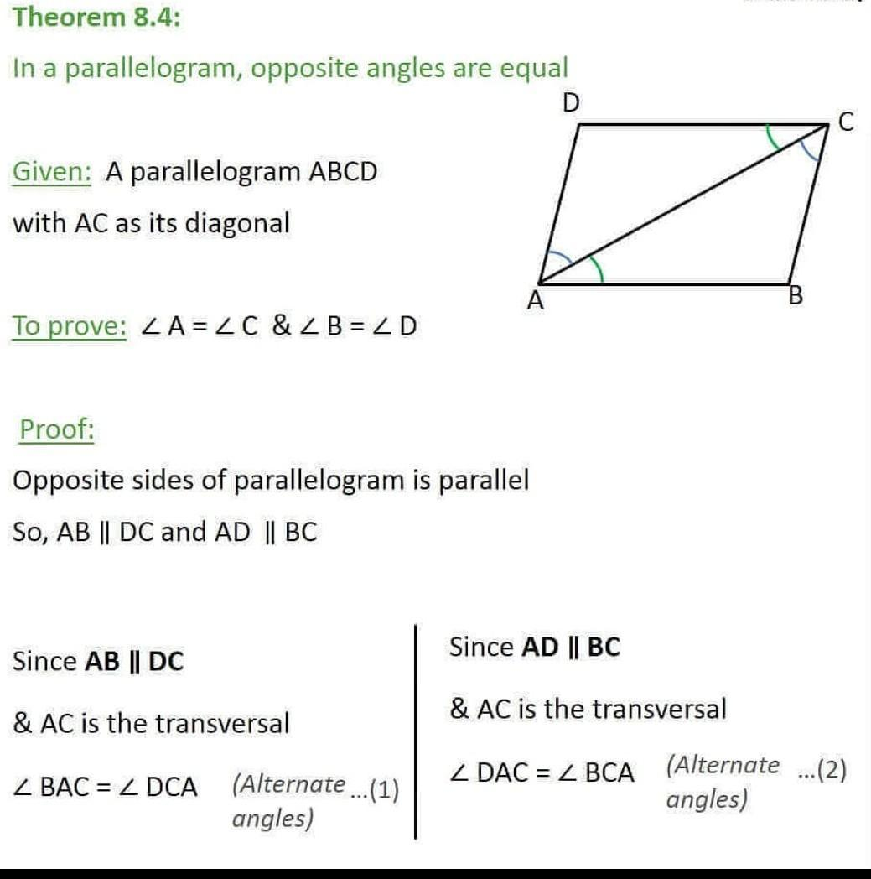
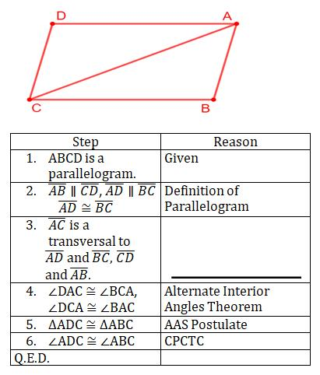
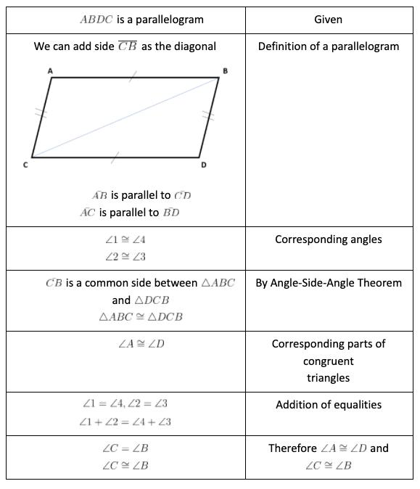
Because $AB∥CD$:
$$∠BAC=∠DCA$$
by alternate interior angles.
Because $BC∥AD$:
$$∠BCA=∠DAC$$
by alternate interior angles.
Also, the diagonal is common:
$$AC=AC$$
Therefore:
$$△ABC≅△CDA$$
by ASA.
Corresponding angles are congruent, so:
$$\boxed{∠ABC=∠CDA}$$
and
$$\boxed{∠BAD=∠BCD}$$
Therefore:
$$\boxed{∠B=∠D}$$
and
$$\boxed{∠A=∠C}$$
Hence, the opposite angles of a parallelogram are congruent.

Example 1
# Source: AI Source: Provided by: [Data Path: Persons Table -> ID Column: 1, Name_En Column: Motasem Essam] -> From: [ChatGPT] on [7/25/2026]
Suppose parallelogram $ABCD$has:
$$m∠A={70}^{∘}$$
Then the opposite angle is equal:
$$m∠C={70}^{∘}$$
Because consecutive angles are supplementary:
$$m∠B={180}^{∘}-{70}^{∘} \\ m∠B={110}^{∘}$$
Therefore:
$$\boxed{∠A={70}^{∘}} \\ \boxed{∠B={110}^{∘}} \\ \boxed{∠C={70}^{∘}} \\ \boxed{∠D={110}^{∘}}$$

Example 2
# Source: AI Source: Provided by: [Data Path: Persons Table -> ID Column: 1, Name_En Column: Motasem Essam] -> From: [ChatGPT] on [7/25/2026]
If:
$$m∠B=3x+10$$
and
$$m∠D=5x-30$$
Since $B$and $D$are opposite angles:
$$3x+10=5x-30 \\ 40=2x \\ x=20$$
Therefore:
$$m∠B=3\left(20\right)+10={70}^{∘}$$
and:
$$m∠D=5\left(20\right)-30={70}^{∘}$$

Main Properties
# Source: AI Source: Provided by: [Data Path: Persons Table -> ID Column: 1, Name_En Column: Motasem Essam] -> From: [ChatGPT] on [7/25/2026]
For parallelogram $ABCD$:
1. First pair of opposite angles
$$\boxed{∠A≅∠C}$$
2. Second pair of opposite angles
$$\boxed{∠B≅∠D}$$
3. Consecutive angles are supplementary
$$\boxed{∠A+∠B={180}^{∘}} \\ \boxed{∠B+∠C={180}^{∘}} \\ \boxed{∠C+∠D={180}^{∘}} \\ \boxed{∠D+∠A={180}^{∘}}$$
4. Sum of interior angles
$$\boxed{∠A+∠B+∠C+∠D={360}^{∘}}$$

Special Cases

Rectangle
# Source: AI Source: Provided by: [Data Path: Persons Table -> ID Column: 1, Name_En Column: Motasem Essam] -> From: [ChatGPT] on [7/25/2026]
All four angles are right angles:
$$∠A=∠B=∠C=∠D={90}^{∘}$$

Rhombus
# Source: AI Source: Provided by: [Data Path: Persons Table -> ID Column: 1, Name_En Column: Motasem Essam] -> From: [ChatGPT] on [7/25/2026]
Opposite angles are congruent, while consecutive angles are supplementary.

Square
# Source: AI Source: Provided by: [Data Path: Persons Table -> ID Column: 1, Name_En Column: Motasem Essam] -> From: [ChatGPT] on [7/25/2026]
All four angles are equal:
$$∠A=∠B=∠C=∠D={90}^{∘}$$

Comparison
# Source: AI Source: Provided by: [Data Path: Persons Table -> ID Column: 1, Name_En Column: Motasem Essam] -> From: [ChatGPT] on [7/25/2026]
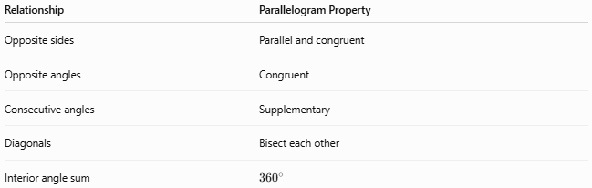
Relationship | Parallelogram Property
Opposite sides | Parallel and congruent
Opposite angles | Congruent
Consecutive angles | Supplementary
Diagonals | Bisect each other
Interior angle sum | $${360}^{∘}$$

Key Points
# Source: AI Source: Provided by: [Data Path: Persons Table -> ID Column: 1, Name_En Column: Motasem Essam] -> From: [ChatGPT] on [7/25/2026]
- Opposite angles are equal in measure.
- There are two pairs of opposite angles.
- $∠A=∠C$.
- $∠B=∠D$.
- Consecutive angles add to ${180}^{∘}$.
- The theorem follows from the parallel opposite sides of a parallelogram.
- Rectangles and squares satisfy the theorem as special cases.

Conclusion
# Source: AI Source: Provided by: [Data Path: Persons Table -> ID Column: 1, Name_En Column: Motasem Essam] -> From: [ChatGPT] on [7/25/2026]
The Parallelogram Opposite Angles Theorem establishes one of the fundamental properties of parallelograms:
$$\boxed{\text{Opposite angles of a parallelogram are congruent.}}$$
For $ABCD$:
$$\boxed{∠A≅∠C, ∠B≅∠D}$$

